Trello
- Open a web browser.
- Search Trello.
- Click on Trello Atlassian.
Name: M.Witty
Roll: 2420030759

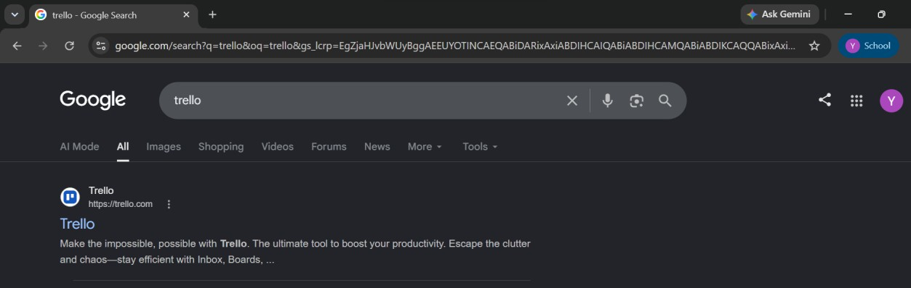
- Sign up or log in using your Atlassian account.
- Create a new Workspace.
- Create a new Board.
- Enter the board name and create it.
- Create lists such as To Do, Doing, and Done.

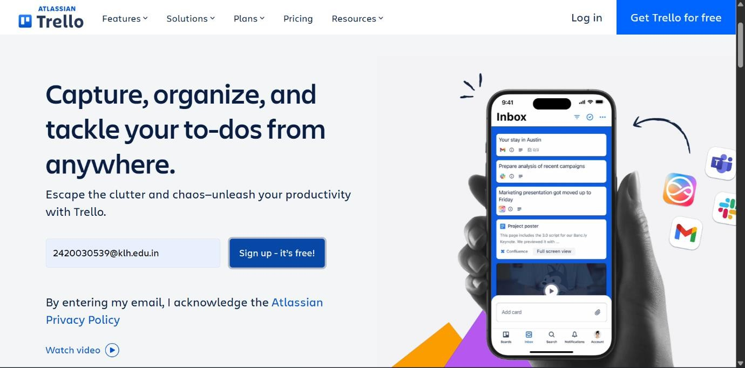
- Add task cards to the To Do list.
- Assign members to the cards.
- Set due dates for tasks.
- Add labels to organize tasks.
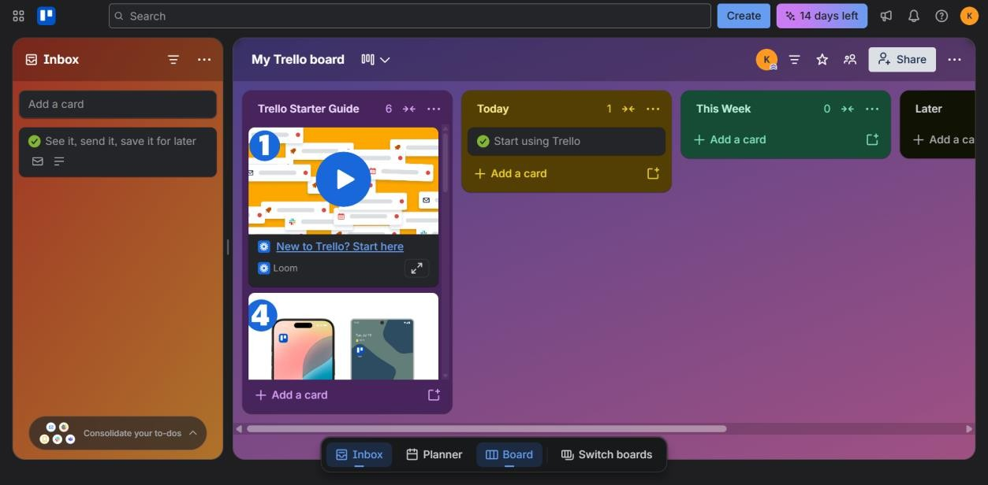
- Attach files or documents if required.
- Move cards from To Do → Doing → Done as work progresses.
- Track the progress of the project using the board.

- Complete all tasks and review the board.

Outcome
Successfully learned how to use Trello for project planning, task management, team collaboration, and project tracking.

